上机3-观察
#include<iostream>
using namespace std;
class Coordinate {
public :
Coordinate()
{
times=2;
cout << "Coordinate construction1 called!" << endl;
}
Coordinate(int times1)
{
times = times1;
cout << "Coordinate construction2 called!" << endl;
}
~Coordinate()
{
cout << "Coordinate destruction called!" << endl;
}
void InputCoord()
{
for (int i = 0; i < times; i++)
{
cout << "Please Input x:" << endl;
cin >> Coord[i][1];
cout << "Please Input y:" << endl;
cin >> Coord[i][2];
}
}
void ShowCoord()
{
cout << "The coord is" << endl;
for (int i = 0; i < times; i++)
{
cout << "(" << Coord[i][1] << "," << Coord[i][2] << ")" << endl;
}
}
void ShowAvgCoord()
{
float avgx = 0;
float avgy = 0;
for (int i = 0; i < times; i++)
{
avgx = avgx + Coord[i][1];
avgy = avgy + Coord[i][2];
}
avgx = avgx / times;
avgy = avgy / times;
cout << "The AVG coord is:" << endl;
cout << "(" << avgx << "," << avgy << ")" << endl;
}
private:
float Coord[100][100];
int times;
};
int main()
{
Coordinate x;
return 0;
}

上机3-添加
#include<iostream>
using namespace std;
class Coordinate {
public :
Coordinate()
{
times=2;
cout << "Coordinate construction1 called!" << endl;
}
Coordinate(int times1)
{
times = times1;
cout << "Coordinate construction2 called!" << endl;
}
~Coordinate()
{
cout << "Coordinate destruction called!" << endl;
}
void InputCoord()
{
for (int i = 0; i < times; i++)
{
cout << "Please Input x:" << endl;
cin >> Coord[i][1];
cout << "Please Input y:" << endl;
cin >> Coord[i][2];
}
}
void ShowCoord()
{
cout << "The coord is" << endl;
for (int i = 0; i < times; i++)
{
cout << "(" << Coord[i][1] << "," << Coord[i][2] << ")" << endl;
}
}
void ShowAvgCoord()
{
float avgx = 0;
float avgy = 0;
for (int i = 0; i < times; i++)
{
avgx = avgx + Coord[i][1];
avgy = avgy + Coord[i][2];
}
avgx = avgx / times;
avgy = avgy / times;
cout << "The AVG coord is:" << endl;
cout << "(" << avgx << "," << avgy << ")" << endl;
}
private:
float Coord[100][100];
int times;
};
int main()
{
Coordinate x;
x.InputCoord();
x.ShowCoord();
x.ShowAvgCoord();
Coordinate y(5);
y.InputCoord();
y.ShowCoord();
y.ShowAvgCoord();
return 0;
}

上机3-创建
#include<iostream>
#include<string>
using namespace std;
class Score{
public:
Score()
{ times=2; }
Score(int times1)
{ times=times1; }
void InputNameAndScore()
{

for(int i=0;i<times;i++)
{
cout<<"请输入学生姓名:"<<endl;
cin>>Name[i];
cout<<"请输入科目A成绩:"<<endl;
cin>>SScore[i][1];
cout<<"请输入科目B成绩:"<<endl;
cin>>SScore[i][2];
cout<<"请输入科目C成绩:"<<endl;
cin>>SScore[i][3];
}

}
void ShowNameAndScore()
{

for(int i=0;i<times;i++)
{
cout<<"姓名: "<<Name[i]<<" 科目A成绩: "<<SScore[i][1]<<" 科目B成绩 "<<SScore[i][2]<<" 科目C成绩: "<<SScore[i][3]<<endl;
}

}
void ShowStdentAvgScore(int Sid)
{

float avg = 0;
avg = (SScore[Sid][1]+SScore[Sid][2]+SScore[Sid][3])/3;
cout<<"姓名: "<<Name[Sid]<<" 平均成绩: "<<avg<<endl;

}
void ShowClassAvgScore(string ClassName)
{
int Cid;
float avg = 0;
if(ClassName == "A") Cid = 1;
if(ClassName == "B") Cid = 2;
if(ClassName == "C") Cid = 3;
for(int i=0;i<times;i++)
{ avg = avg + SScore[i][Cid]; }
avg = avg/times;
cout<<"课程名称: "<<ClassName<<"平均成绩: "<<avg<<endl;

}
void OrderScore(string ClassName)
{

int Cid;
if(ClassName == "A") Cid = 1;
if(ClassName == "B") Cid = 2;
if(ClassName == "C") Cid = 3;
for(int i=0;i<times;i++)
{ SScore1[i] = SScore[i][Cid]; }
for(int i=0;i<times;i++)
{ Name1[i] = Name[i]; }
for(int i=1;i<times;i++)
{ if(SScore1[i] > SScore1[i-1])
{ float temp = SScore1[i-1];
SScore1[i-1] = SScore1[i];
SScore1[i] = temp;
string temp1;
temp1 = Name1[i-1];
Name1[i-1] = Name1[i];
Name1[i]= temp1;
}
}

cout<<"课程名称: "<<ClassName<<endl;
for(int i=0;i<times;i++)
{
cout<<"姓名: "<<Name1[i]<<" 成绩: "<<SScore1[i]<<endl;
}

}
private:
float SScore[100][3],SScore1[100];
string Name[100],Name1[100];
int times;
};
int main()
{ Score x;
x.InputNameAndScore();
x.ShowNameAndScore();
x.ShowStdentAvgScore(1);
x.ShowClassAvgScore("A");
x.OrderScore("B");
return 0;
}

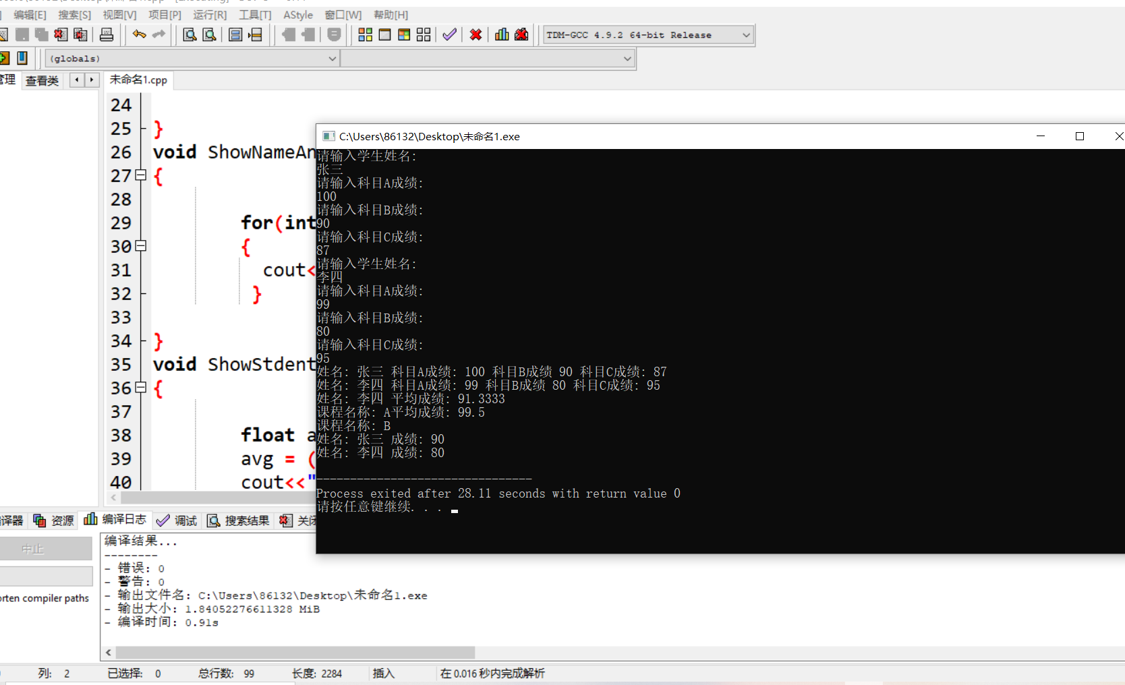
心得
第三次上机，我复习了声明类和定义对象的方法，在类中编写了构造函数和析构函数，验证了它们的执行顺序，对构造函数与析构函数有了一定的了解。

Copyright © 2021-2099 BoYang. All rights reserved.

